**DAILY ONLINE ACTIVITIES SUMMARY**

|  |  |  |  |  |  |  |  |  |
| --- | --- | --- | --- | --- | --- | --- | --- | --- |
| **Date:** | **27-05-2020** | | | | | **Name:** | **SRILATHA K KAMATH** | |
| **Sem & Sec** | **6 B** | | | | | **USN:** | **4AL17CS099** | |
| **Online Test Summary** | | | | | | | | |
| **Subject** | | **System Software and Compiler Design IA TEST 2** | | | | | | |
| **Max. Marks** | | **30** | | **Score** | | | **20** | |
| **Certification Course Summary** | | | | | | | | |
| **Course** | **Career Edge – Knockdown the Lockdown** | | | | | | | |
| **Certificate Provider** | | | **TCS** | | **Duration** | | | **15days** |
| **Coding Challenges** | | | | | | | | |
| **Problem Statement:** Given an array arr[] of the positive integers of size N, the task is to find the largest element on the left side of each index which is smaller than the element present at that index. Note: If no such element is found then print -1. | | | | | | | | |
| **Status: COMPLETED** | | | | | | | | |
| **Uploaded the report in Github** | | | | | **YES** | | | |
| **If yes Repository name** | | | | | https://github.com/alvas-education-foundation/Srilatha-K-Kamath-Daily-Report.git | | | |
| **Uploaded the report in slack** | | | | | **YES** | | | |

Online Test Details:

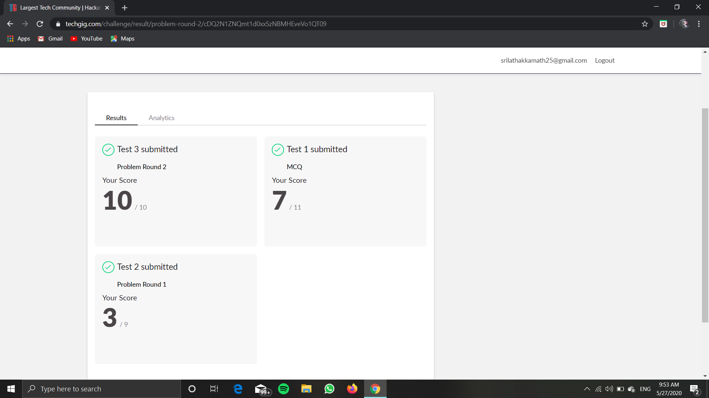

Online Course Details:

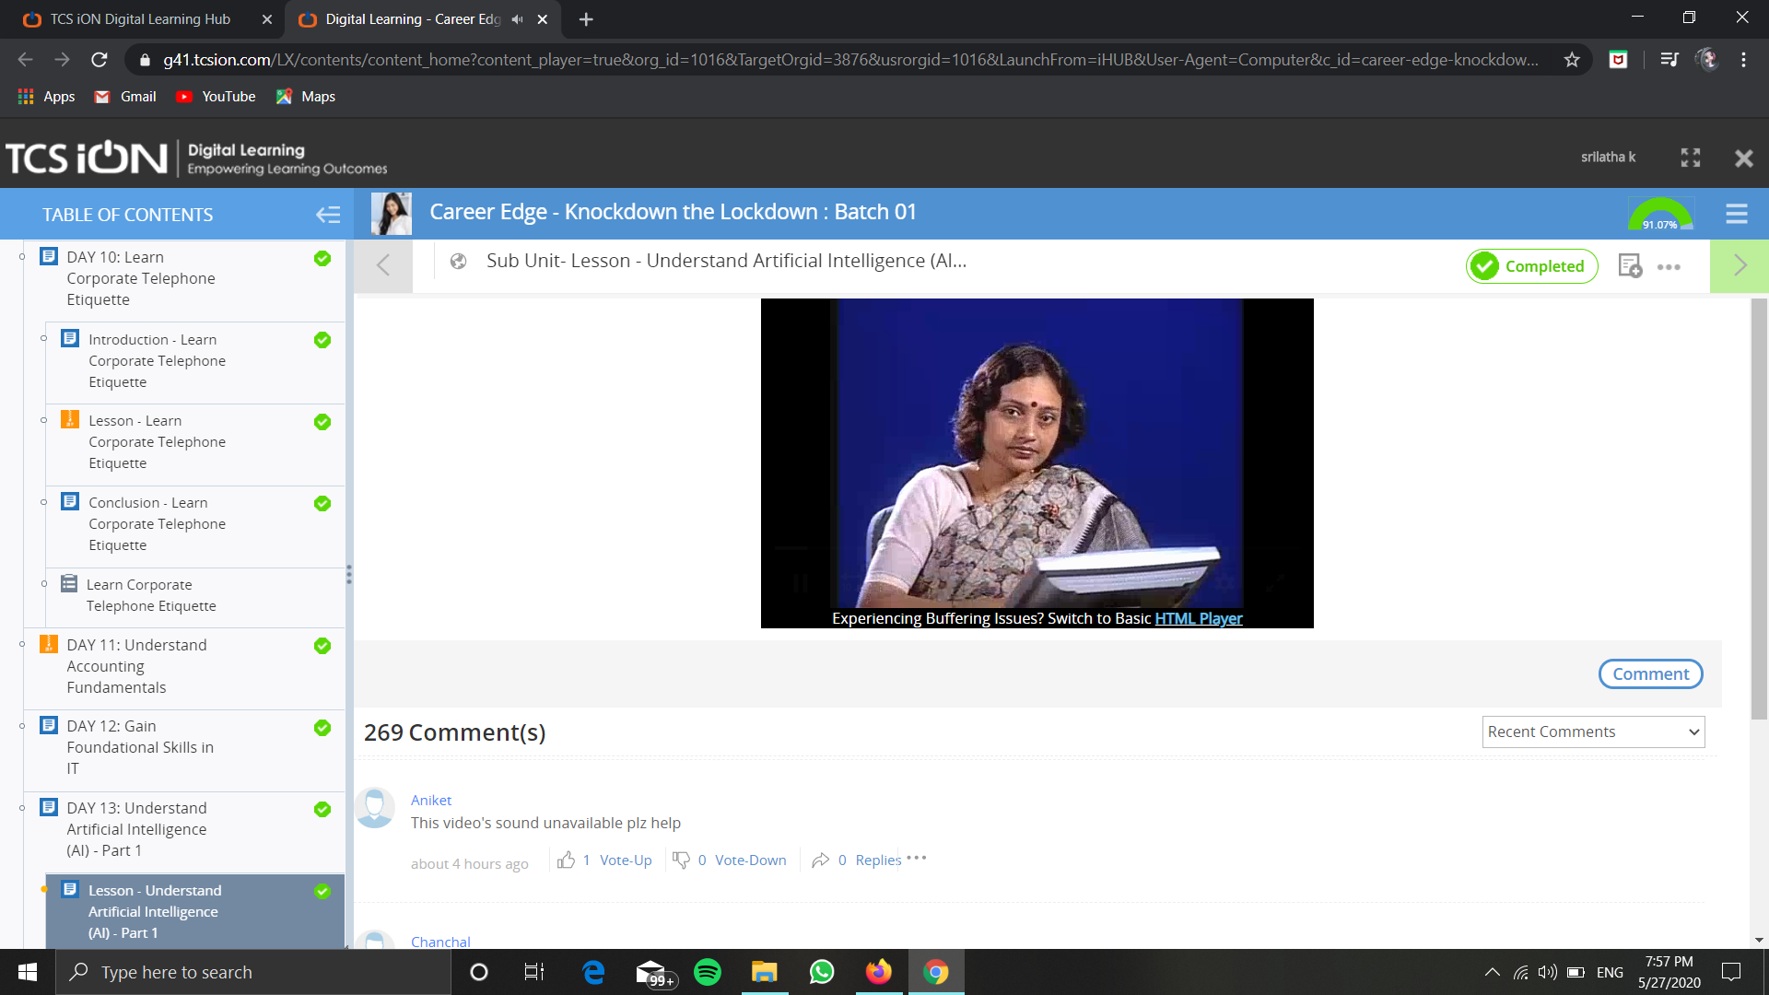

Online Coding Details: 